Excess Portfolio Returns Analysis
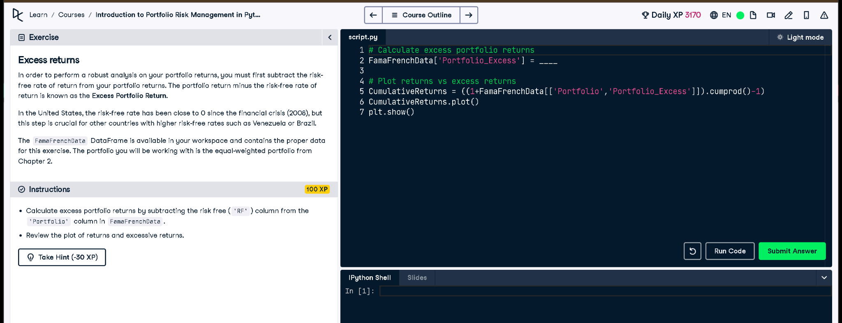
Figure: Exercise interface from DataCamp

Python Code
# Calculate excess portfolio returns
FamaFrenchData['Portfolio_Excess'] = FamaFrenchData['Portfolio'] - FamaFrenchData['RF']
# Plot returns vs excess returns
CumulativeReturns = ((1 + FamaFrenchData[['Portfolio', 'Portfolio_Excess']]).cumprod() - 1)
CumulativeReturns.plot()
plt.show()

Explanation
To measure how well a portfolio performs beyond the risk-free return, we calculate excess returns. This is done by subtracting the risk-free rate (RF) from the actual portfolio return. Then we plot both total and excess cumulative returns to visualize the added value over time.

